RAYALASEEMA UNIVERSITY INTER-COLLEGIATE A-GROUP
TOURNAMENT (MEN):2014-2015 (FROM 24-09-2014 TO 26-09-2014)

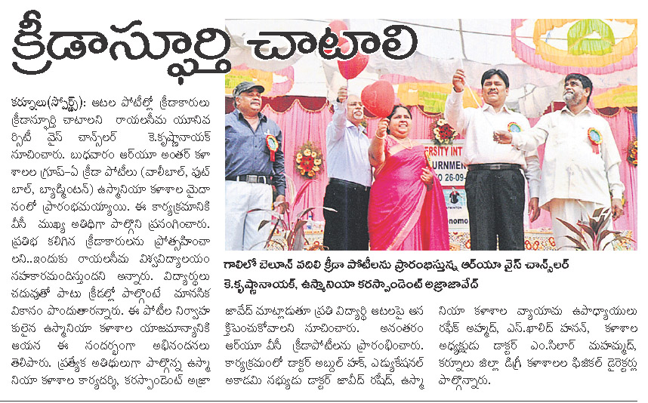
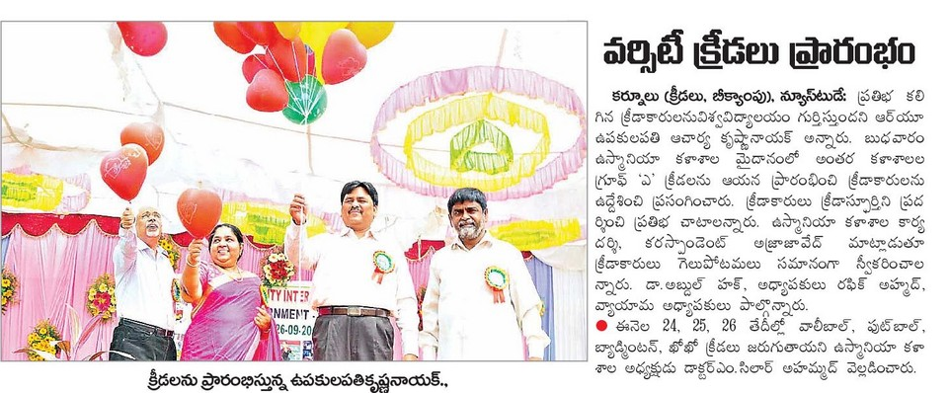

( Published on 25-09-2014 in Eenadu and Sakshi Newspaper- Dist. Edition)

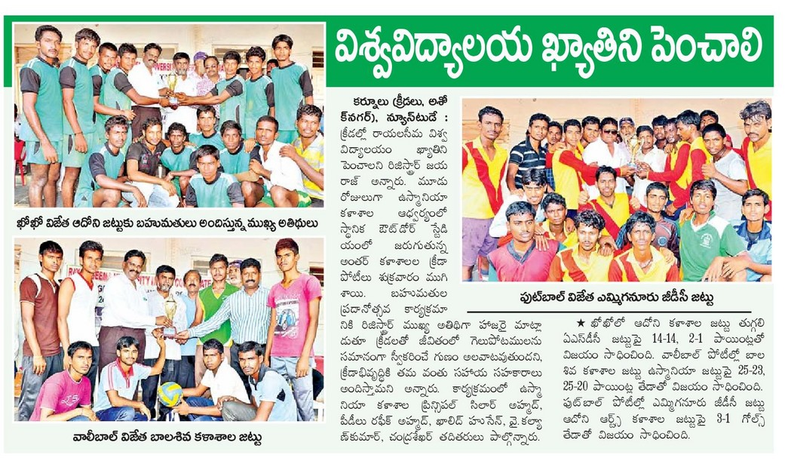
( Published on 26-09-2014 in Eenadu Newspaper- Dist. Edition)
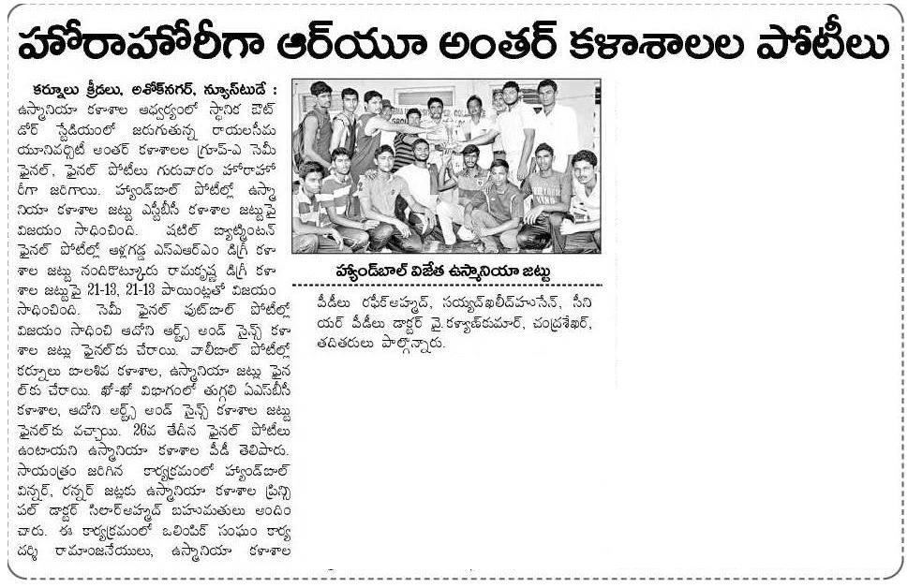

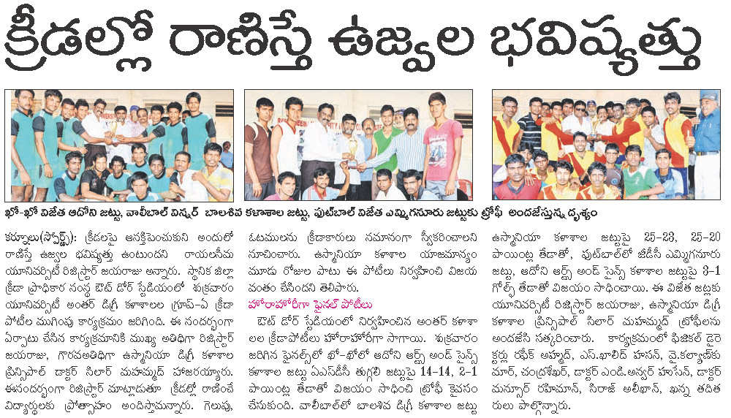

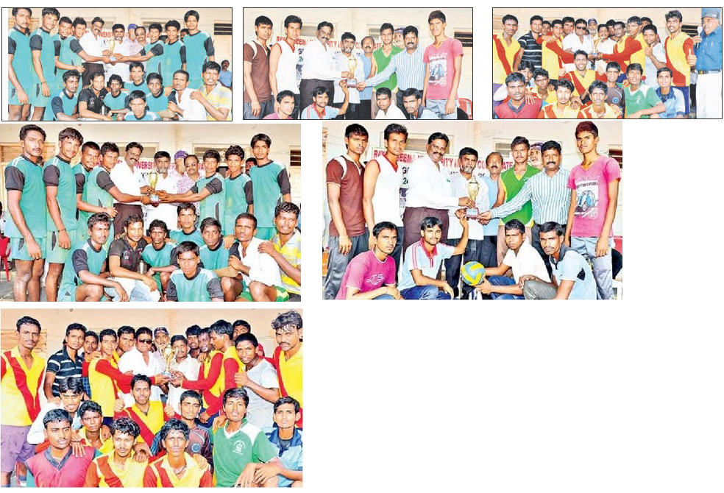
( Published on 27-09-2014 in Eenadu and Sakshi Newspaper- Dist. Edition)

